**///** /Thematic workshop 4 OSLO Air & Water/

**////////////////////////////////////////////////////////////////////////////////////////////////////////**

**Datum**: 27/04/2021: 13:00 – 15:30 CET

**Locatie**: Online - Microsoft Teams Meeting

|  |  |
| --- | --- |
| **Belgian national & regional governments** | Michiel De Keyzer - Digitaal Vlaanderen  Kevin Haleydt - Digitaal Vlaanderen Jurgen Meirlaen, Vlaamse Milieumaatschappij  Geert Van Haute, Departement Omgeving  Annelies De Craene, Digitaal Vlaanderen  Greet Devriese, Vlaamse Milieumaatschappij  Frank Lavens, Vlaamse Milieumaatschappij  Geert Thijs, OSLO-team, Digitaal Vlaanderen |
| **Local administration Europe** | Benjamin Gärtner, City of Heidelberg, Germany |
| **Research institutions** | Fernando López, FIWARE Foundation, Germany |
| **Other** | Stijn Van Hoey, Fluves, Belgium  Niels Melotte, De Vlaamse Waterweg, Belgium  Elien Dewitte - VLIZ - Beligum Laurian Van Maldeghem, Flanders Marine Institute (VLIZ),  Belgium  Gert De Tant - ODALA  Olivier Bernard, ALTIS Groupe SA, Switzerland  Philippe Michiels – ANTSER NV |

**////////////////////////////////////////////////////////////////////////////////////////////////////////**

# Agenda of the workshop

|  |  |  |
| --- | --- | --- |
| **Topic** | **Time (mins)** | **Timestamps** |
| **Start TW4** | 5 mins | 13:05 |
| **Introduction & Who’s in the room** | 5 mins | 13:10 |
| **TW3 Recap** | 10 mins | 13:20 |
| **Changes to the models since TW3** | 40 mins | 14:00 |
| **Break** | **10 mins** | **14:10** |
| **Definitions** | 40 mins | 14:50 |
| **Online Publication** | 15 min | 15:05 |
| **NGSI-LD Alignment** | 10 min | 15:15 |
| **Next Steps** | 10 min | 15:25 |

1. **Introduction & who’s in the room**

We started the workshop with detailing the purpose of the workshop and the agenda (above). The purpose of the workshop was fourfold, namely:

* Giving a recap of the third thematic workshop;
* Going over the changes to core, air & water model since last workshop;
* Going over the online publication flow
* Alignment on NGSI-LD and JSON-LD
* Next steps

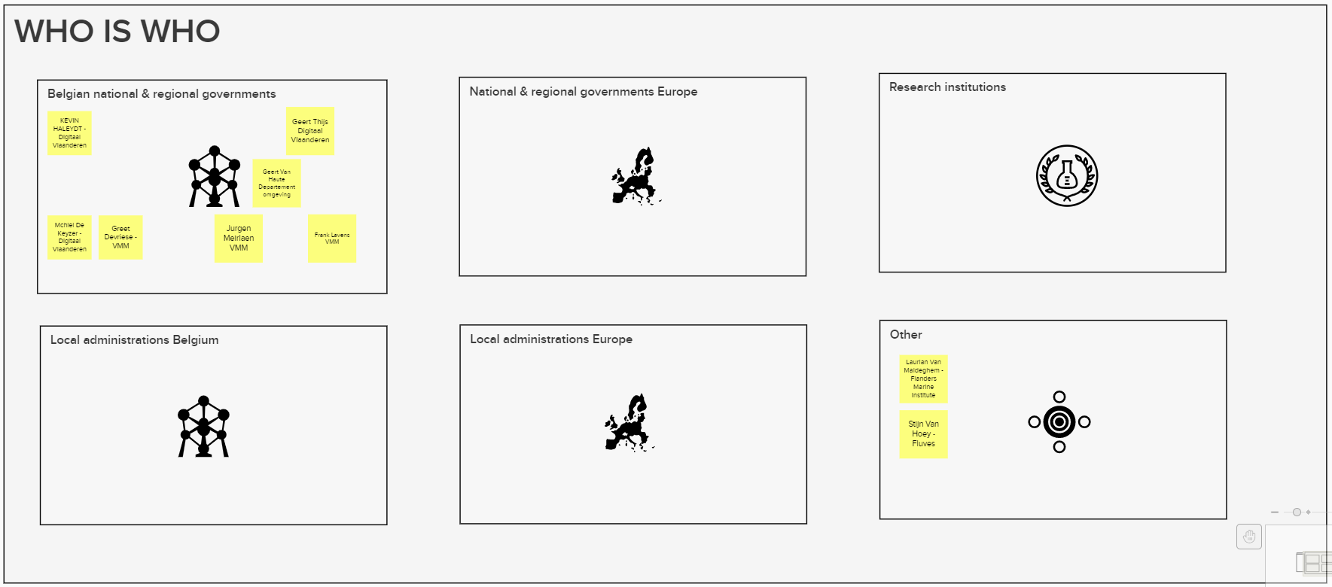

1. **Recap of TW3**

We started the workshop with addressing the comments that were brought up in the previous brainstorm session. The main issues that were brought up were:

* Metadata:
  + Addition of lineage and quality to the model.
  + Metadata should also have a link with ObservationCollection.
* Additional attributes should be added to Device – Sensor – Platform. The attributes of FIWARE device are a good starting point.
* Addition of attributes to the procedure class
* With regards to the Specimen class, we also received the input that there is a need to add automatic sampling and information on the preparation of the sample
* With regards to ObservationCollection, Cube Slice should be added
* The observation class needs a direct relation with sample, and one should also be able to provide the lineage and provenance of the observation.

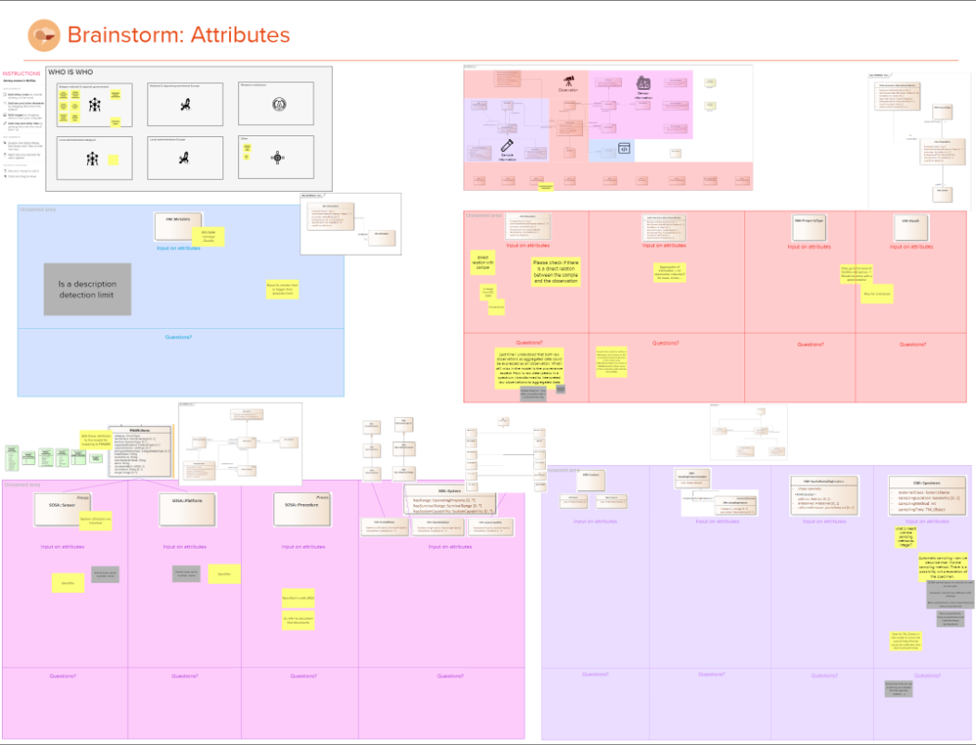

<https://app.mural.co/t/beadvtc7549/m/beadvtc7549/1619423761877/7c32c37861773783943325b084c0ed1bcb46975e>

1. **Changes to the core, Air & Water model**

Core Model

The following changes were added to the Core Model:

1. A relation has been added between Metadata and ObservationCollection.
2. We also added CUBE::Slice to the model as a specialization of ObservationCollection. This is consistent with our analysis done into the CUBE model where a Slice was seen as a specialization of an ObservationGroup.
3. We added attributes to the Metadata class based on the Dublin Core Metadata Initiative (DCMI) [Metadata Terms](https://www.dublincore.org/specifications/dublin-core/dcmi-terms/). The main attributes that were selected were contributor, creator, description, identifier, publisher, rights, subject & title.
4. We added the ObservationContext to the model which allows to contextually link observations to one another (for example provenance).
5. We added two attributes to the ObservationProcedure class, namely type & specification
6. Based on FIWARE Device, we also added attributes to Sensor, System & Platform. This was done by creating a superclass to the model that generalizes System & Platform
7. 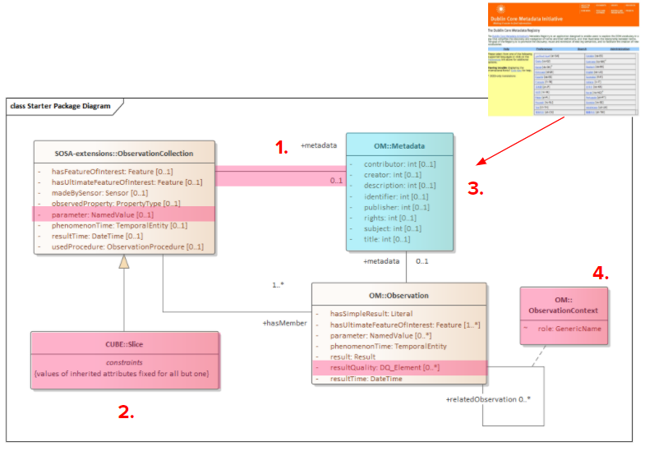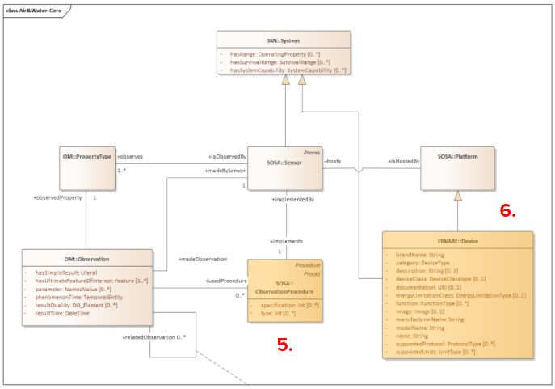Lastly, we added the samplingProcess as well as the Sampling activity and Sampler to the model. This will allow the model to specify more detailed information on the Sampling activity as well as the sampling procedure used as well as give information on the device that was used to sample the specimen.

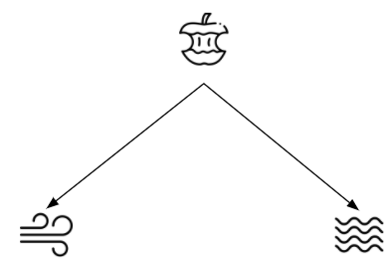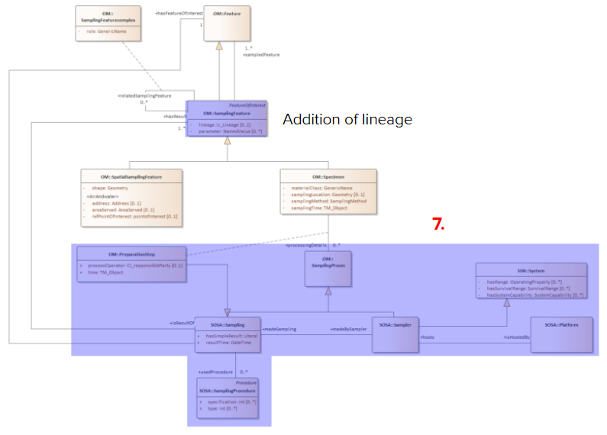

Air & Water model

There were no major changes to the Air and Water models. The main change that happened was a simplification of the models, because there is no need to redefine what’s already present in the core model. All building blocks from the core model can be freely reused in the Air & Water models.

An additional side note to the models is that one should see the Air & Water models in different types of layers (see image below). On the one hand we have the ISO Observations and Measurements model which forms the core of these models. On top of that, our core model is built with additional elements from SSN, SOSA and other relevant models. Lastly, the application profiles of Air and Water have been defined which can reuse elements of the Core and ISO O&M application profiles.

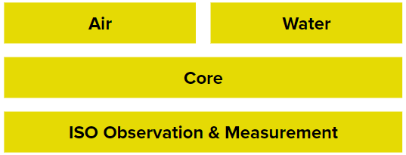

1. **Definitions**

We received some input on the definitions via Github and addressed them during the workshop. Below an overview of the changes that were discussed:

* Observation: Initially, the definition for Observation was taken from ISO O&M and an observation was described as “the act of observing a property”.  
  This was changed to the following definition:  
  “The determination of the value of a particular characteristic of an object at a given time or between two times”.   
    
  The following part of the usageNote will also be deleted: “An observation is the act of observing a property of a feature to come to a result. ~~An observation can be seen as a composed object consisting of components that provide relevant observation details~~”
* With regards to the definitions of Procedure, Platform and System capabilities, we removed the reference to actuation/actuators from the definitions. This decision was taken as actuation is not included in the models.
* PropertyType: No change was made.
* Metadata: No change was made.
* AirFeature & WaterFeature: No change was made.

1. **Online Publication**

A first version of the specifications has been made for the public review and can be accessed via the following links:

* CORE: <https://test.data.vlaanderen.be/doc/applicatieprofiel/AirAndWater/Core/ontwerpstandaard/2021-04-16>
* Air: <https://test.data.vlaanderen.be/doc/applicatieprofiel/AirAndWater/Air/ontwerpstandaard/2021-04-16>
* Water: <https://test.data.vlaanderen.be/doc/applicatieprofiel/AirAndWater/Water/ontwerpstandaard/2021-04-16>

These are currently still in the Dutch templates and will be migrated to the English purl.eu domain during the public review. Please take your time to check the models and provide feedback via the [**Github repository**](https://github.com/Informatievlaanderen/OSLOthema-airAndWater/issues). All input will be processed, and the model will be updated by the end of the public review.

1. **Ngsi-ld alignment**

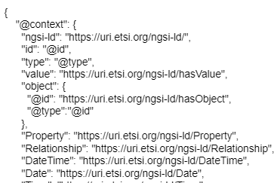Several participants indicated that they work with FIWARE data brokers that exchange information in NGSI-LD format. The main question that rose up was how to be able to communicate with these data brokers and according to the models of OSLO Air & Water.

Similar to JSON-LD, NGSI-LD uses a context in order to give more information on the data that is being exchanged. One key difference however is that NGSI-LD will always include its own [NGSI CORE CONTEXT](https://uri.etsi.org/ngsi-ld/v1/ngsi-ld-core-context.jsonld) to define some core concepts (see extract on the right).

On top of this core context, NGSI-LD allows its users to define your own context file to specify which URIs need to be used. FIWARE shows this in one of their [AirQualityObserved](https://fiware-datamodels.readthedocs.io/en/latest/Environment/AirQualityObserved/doc/spec/index.html) examples (red):

"@context": [

**"https://schema.lab.fiware.org/ld/context",**

        "https://uri.etsi.org/ngsi-ld/v1/ngsi-ld-core-context.jsonld"

    ]

Following this logic, one should specify the [Core](https://test.data.vlaanderen.be/doc/applicatieprofiel/AirAndWater/Core/ontwerpstandaard/2021-04-16/context/OSLO-airAndWater-Core-ap.jsonld) and [Air](https://test.data.vlaanderen.be/doc/applicatieprofiel/AirAndWater/Air/ontwerpstandaard/2021-04-16/context/OSLO-airAndWater-Air-ap.jsonld) or [Water](https://test.data.vlaanderen.be/doc/applicatieprofiel/AirAndWater/Water/ontwerpstandaard/2021-04-16/context/OSLO-airAndWater-Water-ap.jsonld) context files that were created and can be accessed on the dedicated Core, Air & Water model publication pages at the bottom.

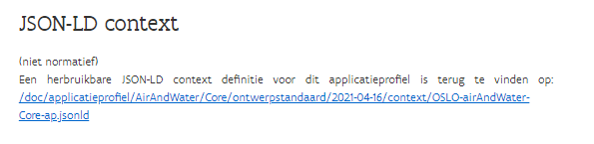

1. **Next steps**

* This was the final workshop and signals the start of the public review period. During this period, we will try to gather as much feedback as possible from the participants as well as other stakeholders working on a proof of concept. You can access the difference models via the following links:
  + CORE: <https://test.data.vlaanderen.be/doc/applicatieprofiel/AirAndWater/Core/ontwerpstandaard/2021-04-16>
  + Air: <https://test.data.vlaanderen.be/doc/applicatieprofiel/AirAndWater/Air/ontwerpstandaard/2021-04-16>
  + Water: <https://test.data.vlaanderen.be/doc/applicatieprofiel/AirAndWater/Water/ontwerpstandaard/2021-04-16>
* If you have feedback on the models or other issues that you think should be addressed, please log these as issues on Github ([**https://github.com/Informatievlaanderen/OSLOthema-airAndWater**](https://github.com/Informatievlaanderen/OSLOthema-airAndWater))or send them via email to [kevin.haleydt@vlaanderen.be](mailto:kevin.haleydt@vlaanderen.be)
* During the public review we will migrate the models to the purl.eu domain, once done we will communicate these links.